the condense statement can be used to remove these blank characters.

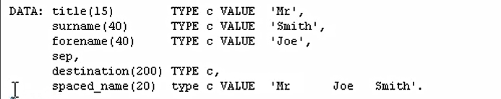

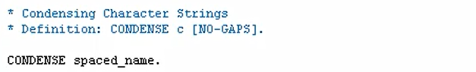

The condense statement will take out the blank spaces between our three words but not fully what it will do. It will leave one space between each word.



So, we should end up with Mr. space Joe space Smith. Let's save the reports. And test it out. You can see Mr. Joe Smith with one space.

